# Linux Environment Variable Assignment

1. Create a script named “myscript” in current directory to do the following.
2. create a dir named “subd1” in current directory.
3. create a file named “dircontent” with contents of the current directory.
4. display the contents of the file “dircontent”.
5. display the contents of a non existing file named “unknownfile”

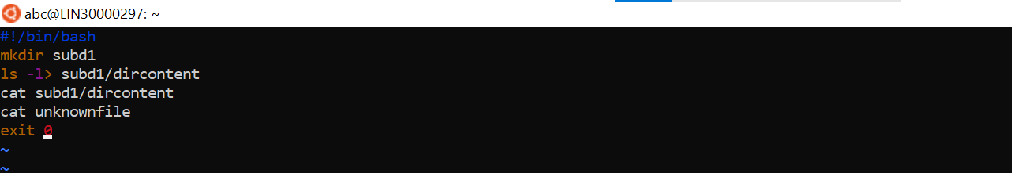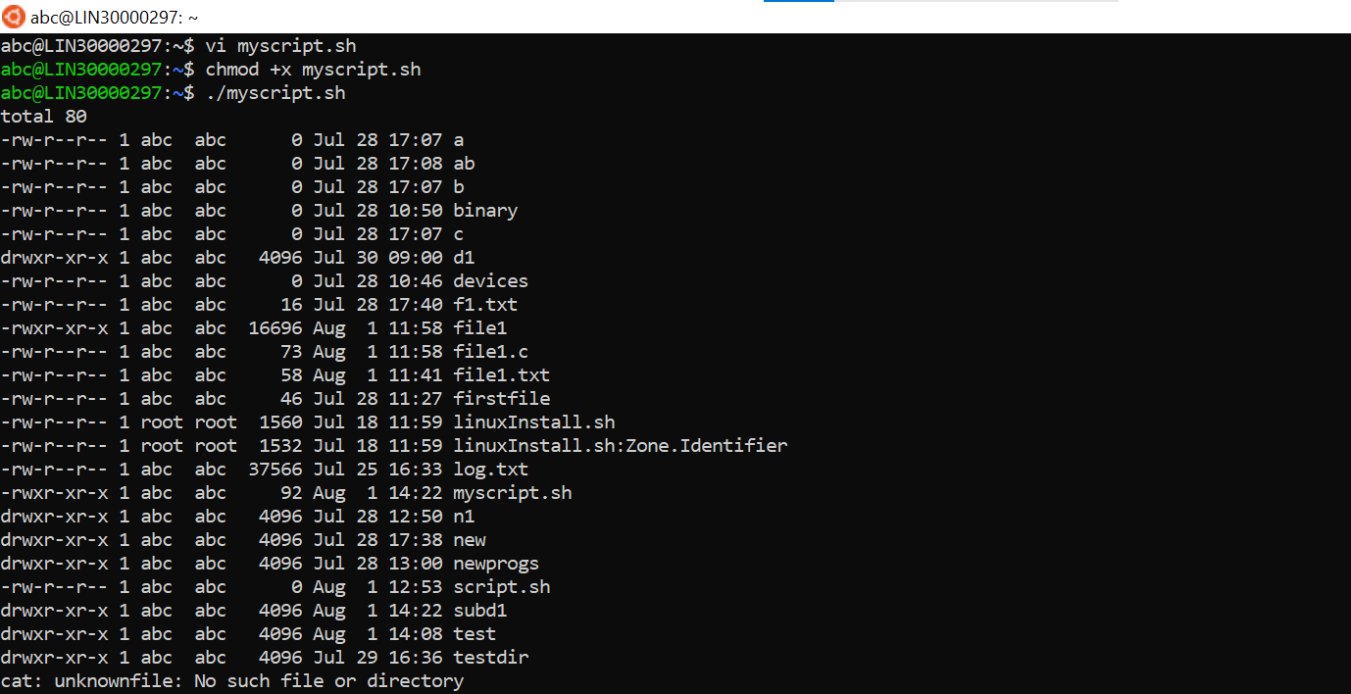

1. Run the script and validate the output in following cases
2. Redirect only the stdout to an o/p file named stdout.txt

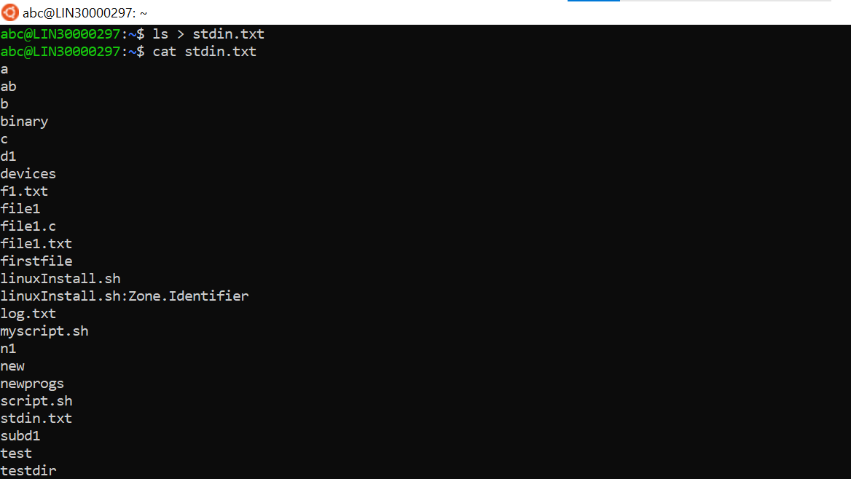

1. Redirect only the stderr to an o/p file named stderr.txt

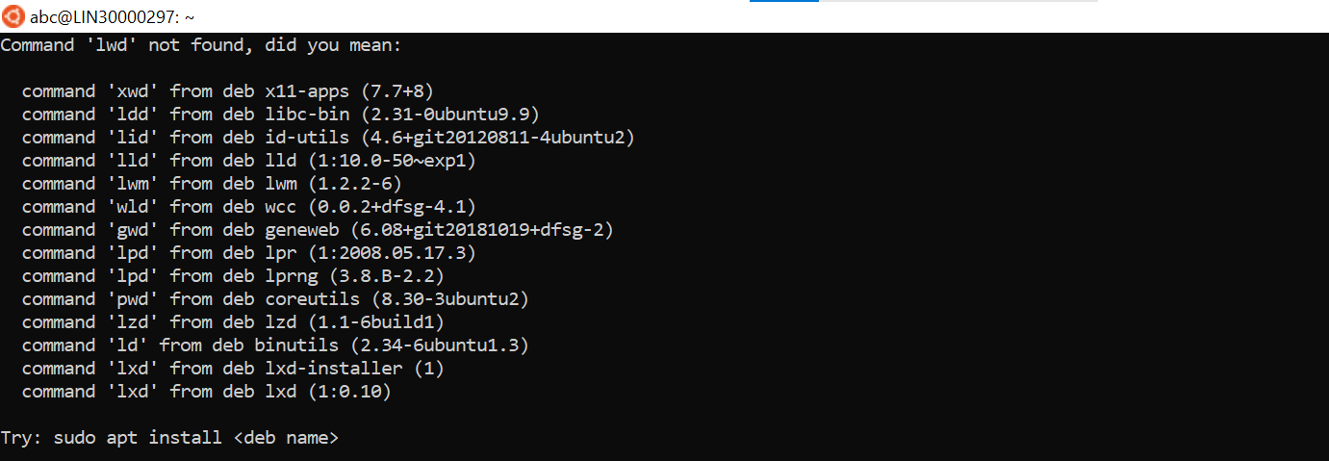

1. Redirect both stdout and stderr to an o/p file named stdall.txt
2. Display all o/p and error and also redirect both stdout and stderr to an o/p file named stdall.txt

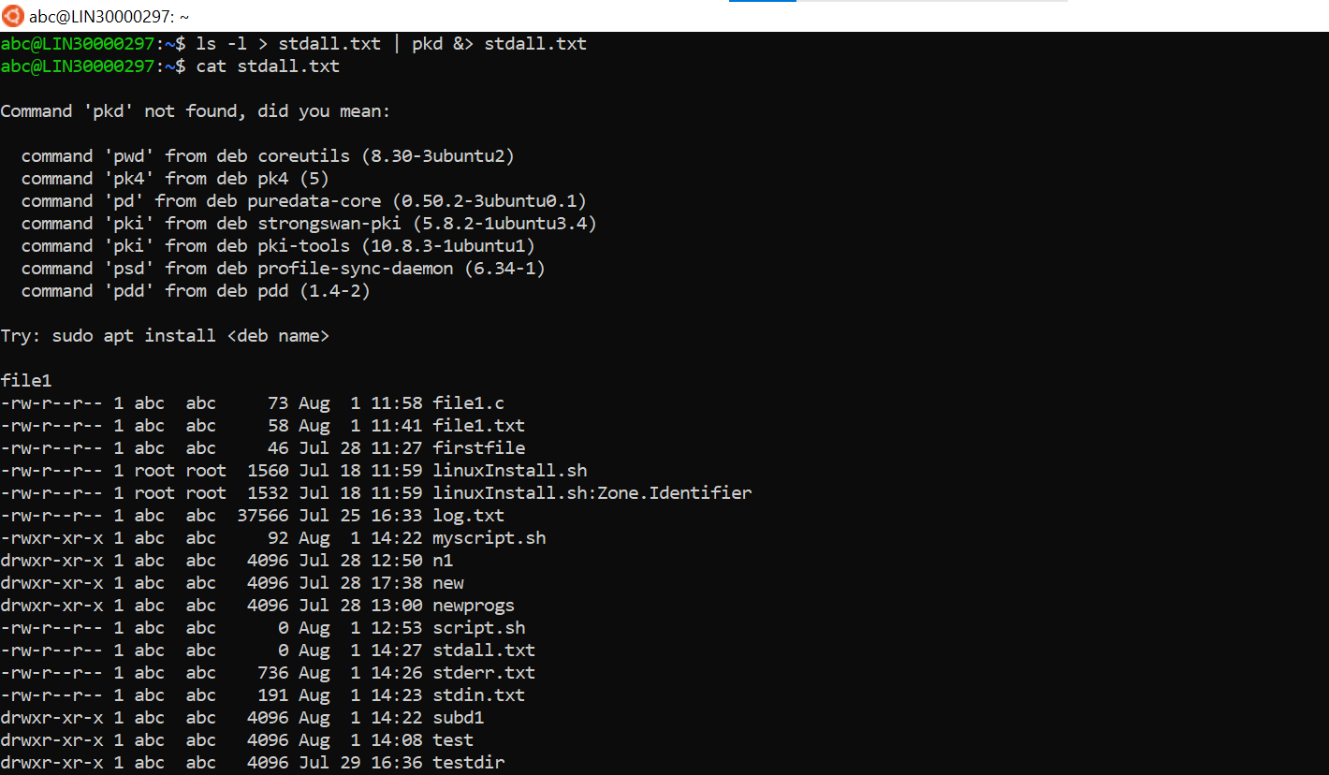

1. Redirect the output of command below using pipe (|) to wc and get the output .

ls -l



**The final Script:-**

